Register formspree

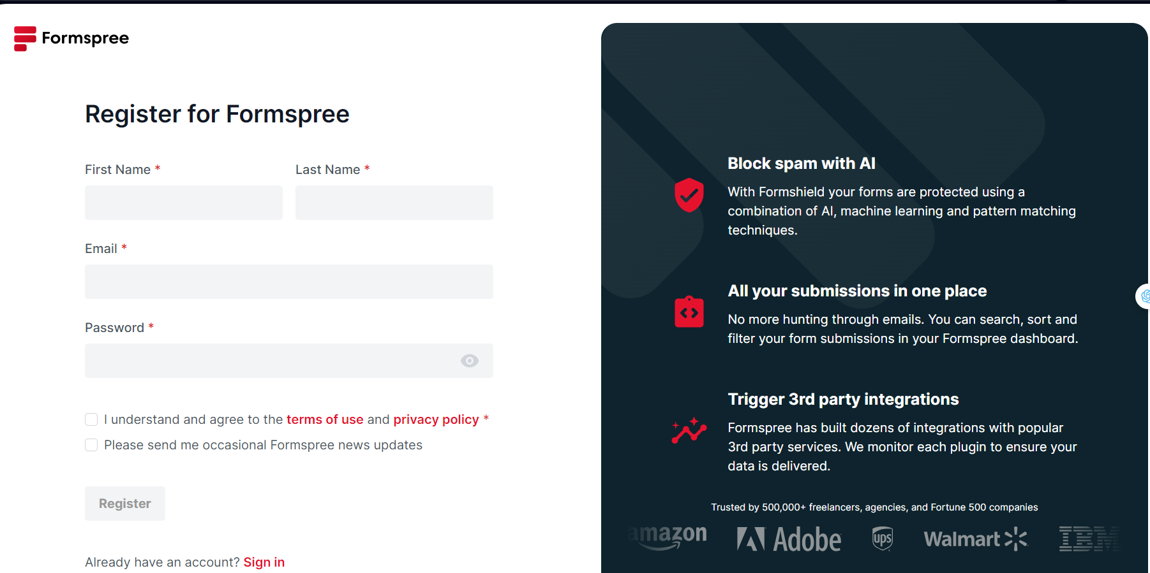

Click new project

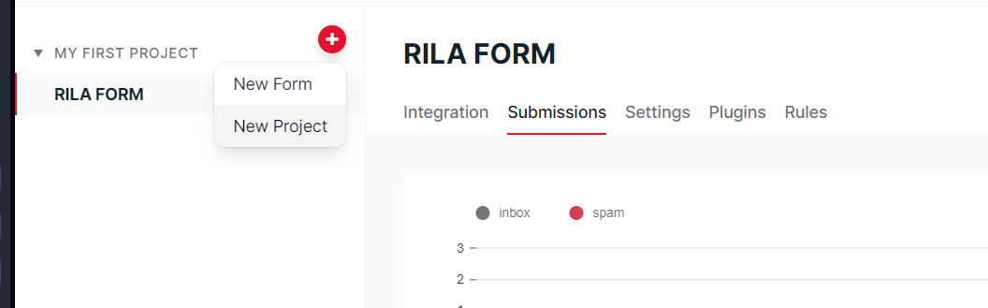

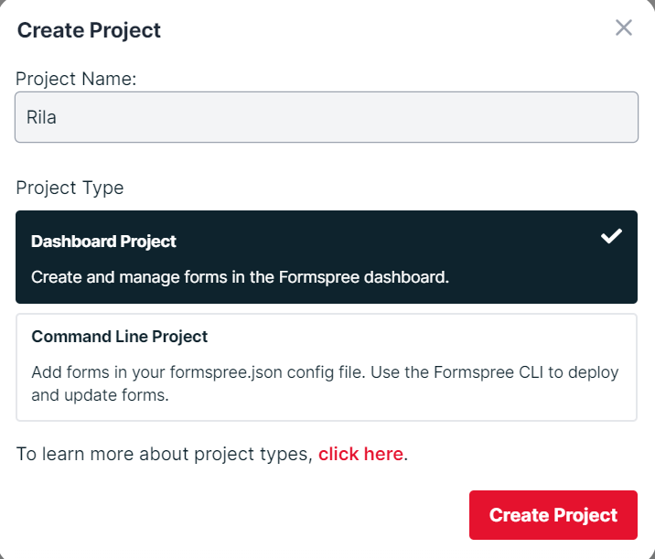

Add form

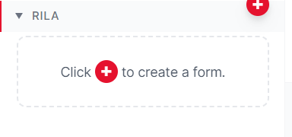

\*\*\*NOTE\*\*\* : Formspree will send email to mail used to register 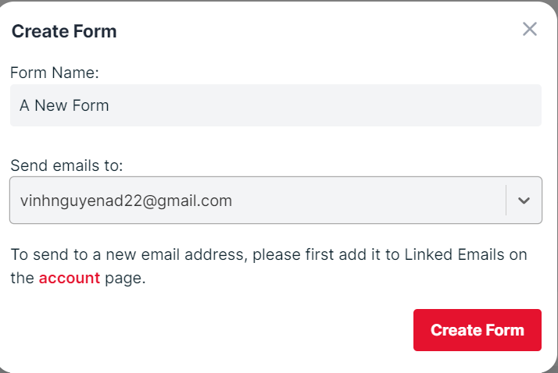

Copy form’s endpoint (Only the text is highlighted in blue) and add to .env file (field FORMSPREE)

